Create the following tables with the given structures and insert sample data as specified: -

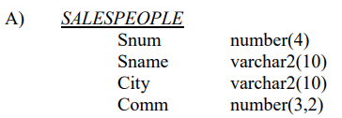

**\*Creation of Table\***

**create table SALESPEOPLE(**

**Snum number(4),**

**Sname varchar2(10),**

**City varchar2(10),**

**Comm number(3,2));**

**\*Insertion of values\***

**insert all**

**into SALESPEOPLE values (1001,'Peel','London',0.12)**

**into SALESPEOPLE values (1004,'Motika','London',0.11)**

**into SALESPEOPLE values (1007,'Rifkin','Barcelona',0.15)**

**into SALESPEOPLE values (1003,'Axelrod','New York',0.10)**

**select * from dual;**

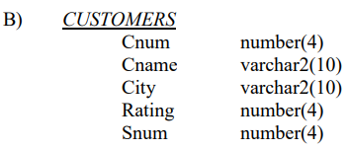

**\*Creation of Table\***

**create table CUSTOMERS(**

**Cnum number(4),**

**Cname varchar2(10),**

**City varchar2(10),**

**Rating number(4),**

**Snum number(4));**

**\*Insertion of values\***

**insert all**

**into customers values (2001,'Hoffman','London',100,1001)**

**into customers values (2002,'Giovanni','London',200,1003)**

**into customers values (2003,'Liu','Barcelona',200,1002)**

**into customers values (2004,'Grass','Berlin',300,1002)**

**into customers values (2006,'Clemens','London',100,1001)**

**into customers values (2008,'Cisneros','San Jose',300,1007)**

**into customers values (2007,'Pereira','Rome',100,1004)**

**select * from dual;**

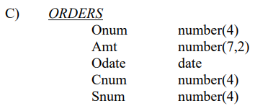

**\*Creation of Table\***

**create table ORDERS(**

**Onum number(4),**

**Amt number(7,2),**

**Odate date,**

**Cnum number(4),**

**Snum number(4));**

**\*Insertion of values\***

**insert all**

**into orders values (3001,18.69,'03-OCT-1990',2008,1007)**

**into orders values (3003,767.19,'03-OCT-1990',2001,1001)**

**into orders values (3002,1900.10,'03-OCT-1990',2007,1004)**

**into orders values (3005,5160.45,'03-OCT-1990',2003,1002)**

**into orders values (3006,1098.16,'03-OCT-1990',2008,1007)**

**into orders values (3009,1713.23,'04-OCT-1990',2002,1003)**

**into orders values (3007,75.75,'04-OCT-1990',2004,1002)**

**into orders values (3008,4723.00,'05-OCT-1990',2006,1001)**

**into orders values (3010,1309.95,'06-OCT-1990',2004,1002)**

**into orders values (3011,9891.88,'06-OCT-1990',2006,1001)**

**select * from dual;**